CM 1020, Introduction to Engineering Graphics, Spring 2023
3D Printer Disassembly Technical Brief
Austin Miller & Anthony Graham

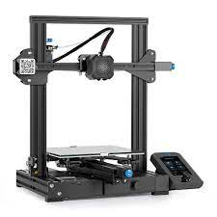
Figure 1: Representation of a 3D printer identical to the disassembly researched

A 3D Printer is a machine that allows one to create a three-dimensional object using a filament of various possible materials that is usually attached for use somewhere on the printer. The machine is commonly used to build prototypes and small, basic parts for other projects. Nowadays, the use of 3D printers is much more common in the final design of projects due to the greater variety of materials available to use in 3D printers.
Table of Contents
Table of Figures 2
Introduction 3
Component Descriptions 4
Fasteners: 4
Joints: 5
Springs: 6
Bearings: 7
Gears and Pulleys: 8
Belts: 9
Mechanism Description and Components 10
Summary/Conclusions 12
Bibliography/References 13

Table of Figures

Figure 1: Representation of a 3D printer identical to the disassembly researched 0

Figure 2: Basic labeling of 3D printer components 3

Figure 3: Components fasteners commonly assist in holding together 4

Figure 4: Printer Extruder; Assists in dispensing 3D filament 10

Figure 5: Variety colored 3D Filament 11

Figure 6: Popularly used 3D printer control board 11

Figure 7: 3D Printer in the process of generating a 3D printed project 11

Introduction
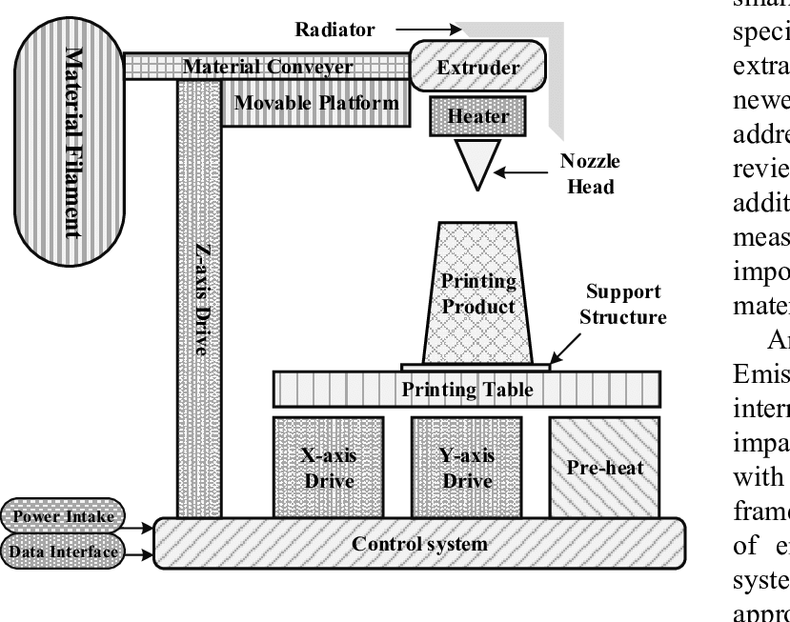
The 3D printer, which is also known as additive manufacturing, is a very useful machine that allows people to rapidly produce objects and prototypes. The machine allows for a much more efficient way of creating objects. With the 3D printer, there is no need to worry about cutting away excess material and adding extra material. The machine uses a pen that lays down layers and layers of material in the shape of whatever object is desired until the object is completely formed using the filament from the printer. To create the objects that the users desire, a 3D printer goes through 3 different technological processes, which are sintering, melting, and stereolithography. The process of sintering is where the machine heats the material being used for the printer to prepare for use. Melting is the process that the 3D printer uses to melt the material together to form the shape desired. Finally, stereolithography uses lighting from the machine to fully solidify the object after being formed. Of course, to be able to create the objects at all, the printer needs the 3D-modeled design of the object to replicate. For this, CADD (Computer-Aided Design and Drafting) software is used to import the design of the object desired into the 3D printer to be printed. The process of 3D printing is a far faster and more cost-effective way of producing products due to the machine being able to produce various objects in rapid succession and being able to do so using cheaper material than what would be needed to produce it any other way.
Figure 2: Basic labeling of 3D printer components

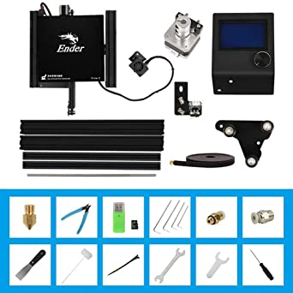
Component Descriptions
Figure 3: Components fasteners commonly assist in holding together

Fasteners:
Fastener is a term used to group tools such as nuts, bolts, screws, washers, and rivets. together under a single name. The purpose of these tools is to keep the components of a mechanical system together securely. The benefit of a fastener over another adhering method such as glue is the benefit of being able to remove the fasteners to take apart the mechanical system when necessary, making them non-permanent. There are 3 methods of creating a fastener. Cold forming is the method of forming the fastener without any heat, pressing or striking the metal until it fits into a form or cast. Hot forging is the process of melting metal until it is soft enough to be put into a cast for molding. Finally, machining is when metal is cut away into the shape of the desired fastener.
When deciding what kind of fastener is needed, 3 key elements must be known. The material(s) the fastener is holding together, the dimensions of the material(s) being held, and the purpose of the fastener. The material(s) will inform you what type of fastener you need, such as a screw for wood or a bolt for steel, the dimensions will allow you to determine the size and dimensions of that specific fastener, and the purpose will finalize the type of that specific fastener needed, such as hex-head bolt for simple metal adhesion. The many variations of these fasteners are meant to maximize the efficiency of each circumstance. Bolts and screws are meant to hold unthreaded parts together, while nuts and washers are meant to secure threaded parts with bolts or screws. Each of these, however, goes into more complex variations, such as a U-bolt for fastening pipes, or a tri-fold rivet for a strong semi-permanent fastening.

Joints:
Many mechanical systems have moving parts, and these parts need to be able to safely and smoothly perform their tasks. Joints are when two components join to create a moving component within a mechanical system. The parts of a joint are typically manufactured separately through methods similar to fasteners, such as hot forging and machining. The parts of the specific joint are then brought together to be assembled into a single mechanical component. Where and when this happens depends upon the type of joint, as each joint must be conjoined at different stages in the manufacturing process of the overall mechanical system. For example, a hinge would be manufactured before being added to something such as a door or door frame, while a ball and socket joint is only conjoined while the larger mechanical system is being manufactured or assembled.
When deciding what kind of joint is needed, the purpose of the joint needs to be considered, as well as the goal of the joint. If a mechanical component needs freedom of movement vertically within a certain angle, knuckle joints are necessary for this purpose. However, if a component needs to move in a circle perpendicular to another component, a revolving joint may be the best option. The difference in joints is primarily based on the direction, speed, and space the joint must fill. Each joint is meant to allow movement in specific directions, at certain speeds, and is made to fill in specific spaces. An example is the different types of drive axle joints in cars. Some cars have different gear ratios, sizes, and angles for their axle joints, as they are meant to fit the specifications of the larger mechanical system that is the automobile.

Springs:
An elastic mechanical component, springs are meant to store mechanical energy and disperse it accordingly. This is usually evident in how a spring either pushes back or pulls against the force being applied to it. They are manufactured through a 4-step process. First, the springs are wound into the correct shape, size, and strength necessary for the job it will be used in. Next, the spring is heat treated to retain this new shape and relieve any stress being acted upon the metal from being bent into a spring. Then, the spring’s edges are ground smooth and flat to fit the space it needed to fit into. Finally, the spring undergoes a coating and finishing touches are added to combat other possible problems the spring may face, such as rust or erosion from the weather.
There are many types of springs, and each one has a different role depending on where it is needed within a mechanical system. To know what springs are needed, the direction(s) and strength of the force being applied to the spring must be known. A more intense force being applied directly onto a spring, disk springs may help. but if the force is being applied opposite of the spring, such as a pulling force, extension springs are best. The many variations of springs are designed to help in different situations. There are well over 15 different springs that are used in modern technological equipment. Some of these include torsion, compression, flat, and serpentine springs. These specifications again are dependent upon the direction and strength of the force being applied, as well as the space the spring has to fit into.

Bearings:
Many machines in the world have some aspect of rotation in them and the component that allows for that rotation in these machines is none other than bearings. Bearings are usually connected to a shaft located inside of a machine to allow for the shaft to rotate, therefore allowing whatever part requires rotation to rotate. Bearings are very commonly used in generators, cars, and airplanes. This component reduces the friction that occurs between the shaft whatever is supporting the shaft’s rotation. This allows for smooth rotation within the machine. To manufacture bearings, a lot of different processes are put into play to create the final product. The company must first determine the material they need to use for the bearing and then use a special machine to cut the material into the correct shape for the bearing. After cutting the material into a ring shape, the bearing must be ground to the exact dimensions desired. Once it is finished being ground into exact measurements, it is heated so that the material may harden and be dipped in oil. The finishing touches of the bearing then include making sure the surfaces are smooth and adding on the bearing’s specifications and manufacturing details.
To purchase these bearings for projects, a couple of specifications must be known to the buyer before purchasing them. One of these specifications is the diameter. The buyer must know exactly how large the bearing must be so that it may fit perfectly onto the shaft to which they will be attaching it. It is very important that the bearing is not too large or else it will just fall off the shaft repeatedly, and it cannot be too small or else it will not fit on the shaft at all. The other specification the buyer of bearings should know is what material they want the bearing to be. Depending on the project the buyer is using the bearing for, certain bearing materials may be inadequate for the machine. With bearings, the only variations in it are their size and the material it is made of.

Gears and Pulleys:
Gears are toothed circles that interlock with one another to create a chain and transport rotational energy from one location to another. Pulleys are a system of at least 2 circles that can guide a wire, belt, or another form of loop to transfer energy. Both pulleys and gears have similar yet complex methods of manufacturing, requiring a combination of casting, forging, machining, and additional methods depending on the type of pulley or gear. These methods are dependent because the gear or pulley must be a certain shape, size, and strength to complete its task. An example of this is extrusion for gears, which is when a larger heated metal profile through a smaller shape, results in a smooth and hardened gear. This method is not common though due to the fact it is not an economically friendly process to a degree.
For gears, the size and teeth are necessary information to know when determining what kind of gear is needed. The number of teeth on a gear is directly proportional to how much power and how long it takes for that power to be transported to the location it is needed. As for pulleys, it is more important to know how many pulleys will be included in the system. The more pulleys there are, the more power can be transported. So, if a system requires a small amount of power, only a couple of smaller pulleys are necessary. But, if a large amount of power is needed to be transported, more and larger pulleys may be needed, depending upon the goal. Both gears and pulleys have varied types. The different gears are based on how the gear interacts with other gears, which include worm and spur gears. Worm gears are placed perpendicular to another gear and twirl in place, forcing the connected gears to turn. Pulleys are different based on how the line used within the pulley system is used. A compound pulley uses 2 pulleys to lift an object from one of the pulleys, while a fixed pulley system lifts an object from a fixed location.

Belts:
Belts are a tool that aids in the rotational force of other components and creates energy. They are commonly used to transport other items but are also used in complex mechanical systems, such as an automobile. They rotate around two fixed positions, and the rotation creates and helps sustain energy from a motor or other energy source. Belts are usually manufactured with rubber or another malleable material. This allows the belt to be bent around the two wheels in the belt drive and not sustain damage or break. The belts are manufactured to work with specific fixed positions or even pulleys in some cases and therefore are designed to fit them perfectly.
To know what kind of belt is needed, the direction of the belt is the most vital information. If 2 pulleys go in opposite directions, a cross-belt drive is necessary, but a single direction requires an open-belt drive. These different types of belt drives are meant to help aid in the specific needs of the pulley system that is used in the mechanical system. This in turn is what leads to different kinds of belts and the materials they are made of, such as the difference between a bike chain and a timing belt on an automobile.

Mechanism Description and Components
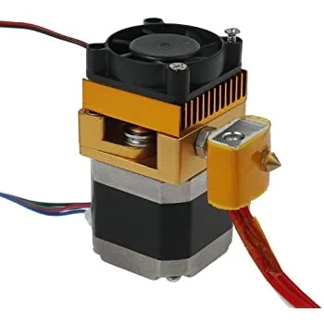
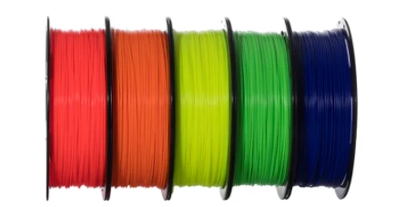
Giving people the ability to produce three-dimensional objects using few materials and low-cost materials, 3D printers provide a much more efficient way of creating parts and prototypes for machines. The use of 3D printing has opened doors for many different applications in life. It is used to make prosthetics, movie props, dental products, fossil reconstruction, and so much more. Car manufacturers and aviation have also made use of 3D printing for faster manufacturing and lightweight material. Using its pen that is connected to a mechanical arm, the 3D printer dispenses the filament that is stored in the printer and lines it up in the shape of the design that has been exported to the printer from design software. The printer then continues lining the filament on top of each other until the object is complete. To understand how the 3D printer can perform these tasks, it is important to know all the parts of the 3D printer and how they all operate together to allow the printer to do what it does. First is what is usually an 8-bit or 32-bit controller board that commands the printer to do all the tasks it performs. Next is the filament, which you can purchase in types such as PLA, ABS, PET, TPE, Nylon, PVA, or HIPS. The filament is the material that is used to make whatever object the printer is tasked to create. The frame is what holds all the electrical components of the 3D printer, without it, there would be no printing device to use. To be able to print the object desired in 3D, the printer needs a print bed that can be made of either aluminum or glass and be heated or unheated. This is what the final printed product is made on. Finally, a very important part of the printer is the print head which usually comes with a brass 0.4mm nozzle. This piece is what guides the filament in the right direction to form the shape needed. Various smaller parts are held within the printer that includes:
Figure 4: Printer Extruder; Assists in dispensing 3D filament
Figure 5: Variety colored 3D Filament
- Stepper Motors (20-25 N cm, 40-45 N cm, or 50-56 N cm)
- Rubber Belts (Usually with a width of 6mm, height of 1.38mm, and tooth height of 0.75mm)
- Threaded Rods
- Mechanical & Optical End Stops
- Power Supply Unit (12 or 24V DC)

- Feeder System (Direct or Bowden Extruders)
Figure 6: Popularly used 3D printer control board
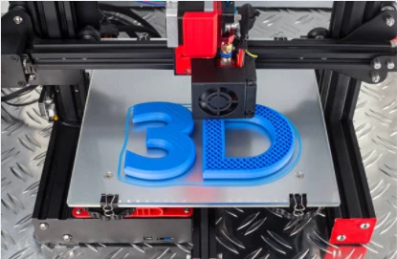
Figure 7: 3D Printer in the process of generating a 3D printed project

Summary/Conclusions
Understanding the most common mechanical components used in engineering is necessary to start to learn more complex and advanced mechanical systems. This basic knowledge allows us to learn about additional components as well as how they are related and work together to create a mechanical system. Continuing into the next steps of our careers, we can also use the information we learned about 3D printers to understand the benefits of using one in an engineering environment. This machine allows the easy and quick creation of various projects and components, without the need for highly advanced and expensive machines to bring your ideas into modern applications.
The 6 basic components we studied were fasteners, joints, springs, bearings, gears, and pulleys, as well as belts. Each of these components is very common in modern mechanical systems, and their applications are vast due to the many variations of each component. Many of these components are even used together, to create a more complex system of components to fulfill a job. An example of this is a 3D printer, which utilizes 6 main components. Stepper motors, rubber belts, threaded rods, mechanical and optical end stops, a power supply unit, and a feeder system. These primary components are what allow the machine to complete the task it is given, and it also shows how each part in a mechanical system has a purpose that is meant to serve the greater overall goal of the machine.

Bibliography/References
- “Fasteners 101: Types of Fasteners and How to Choose the Right One.” Rapiddirect, 8 Dec. 2022, https://www.rapiddirect.com/blog/types-of-fasteners/
- Pinchback, Joseph. “What Are Fasteners? & Other FAQs.” Bing, Microsoft, 5 Sept. 2022, https://www.bing.com/search?q=how%2Bfasteners%2Bare%2Bmanufactured&qs=UT&pq=how%2Bfasteners%2B&sk=UT1&sc=10-14&cvid=3EFCA3A28BB84750B250D5CA1591038E&FORM=QBRE&sp=2&ghc=1&lq=0
- “3D Printing: What You Need to Know.” PCMAG, https://www.pcmag.com/news/3d-printing-what-you-need-to-know#:~:text=Designers%20use%203D%20printer%20 to,and%20 novelty%20items%2C%20and%20 toys
- “What Is a 3-D Printer? - Definition from Techopedia.” Techopedia.com, https://www.techopedia.com/definition/28405/3d-printer
- “What Is 3D Printing? - Technology Definition and Types.” TWI, https://www.twi-global.com/technical-knowledge/faqs/what-is-3d-printing
- Brent. “What Is a Mechanical Joint?: Blog Posts.” OneMonroe, 26 Mar. 2020, https://monroeengineering.com/blog/what-is-a-mechanical-joint/
- “What Are Bearings? Let's Learn about the Basic Functions of Bearings!” / Bearing Trivia / Koyo Bearings(JTEKT), https://koyo.jtekt.co.jp/en/2019/06/column01-01.html.
- “Mechanical Joint.” Mechanical Joint - an Overview | ScienceDirect Topics, https://www.sciencedirect.com/topics/materials-science/mechanical-joint
- Usa, Spb. “Ball Bearings: SPB-USA, LLC.” USA, 25 Feb. 2022, https://www.ezo-usa.com/news/how-are-ball-bearings-made/.
- M, Saif. “15 Different Types of Springs and Their Applications [Pdf].” The Engineers Post, 28 June 2022, https://www.theengineerspost.com/types-of-springs/
- IDC Spring. “How Are Springs Made - the Spring Manufacturing Process -.” IDC Spring, 21 May 2021, https://idcspring.com/spring-manufacturing-process/#:~:text=These%20steps%20are%20explained%20in%20detail%20below%3A%201,for%20it.%20...%204%204.%20 Coating%20and%20 Finishing
- “Gear Manufacturing 101: A COMPLETE Guide on Gear Production Processes.” Rapiddirect, 2 Aug. 2022, https://www.rapiddirect.com/blog/gear-manufacturing/
- Richard. Wolter. “Pulley vs Gear: What's the Difference?” Illinois Pulley & Gear, Illinois Pulley & Gear, 23 Aug. 2022, https://illinoispulleyandgear.com/pulley-vs-gear-whats-the-difference/
- Smith, Marshall. “A Brief History of Pulleys and How They Are Made Today.” Industry Tap, 8 Dec. 2016, https://www.industrytap.com/brief-history-pulleys-made-today/39832#:~:text=So%20how%20are%20pulleys%20made%3F%20To%20make%20a,is%20then%20sent%20off%20to%20the%20molding%20phase
- “What Is 3D Printing? How Does a 3D Printer Work? Learn 3D Printing.” 3D Printing, 3DPrinting.Com, 26 Jan. 2023, https://3dprinting.com/what-is-3d-printing/.
- “3D Printers Components - How 3D Printers Work.” VLC Components S.l., https://solectroshop.com/en/blog/3d-printers-components-how-3d-printers-work-n40.

